**PROJECT ASSIGNMENT**

Tools used : Git, Jenkins, Maven, Docker & Dockerfile, Ansible

1. **For dev-A**

**Build success for launching two containers using Dockerfile on dev-A machine.**

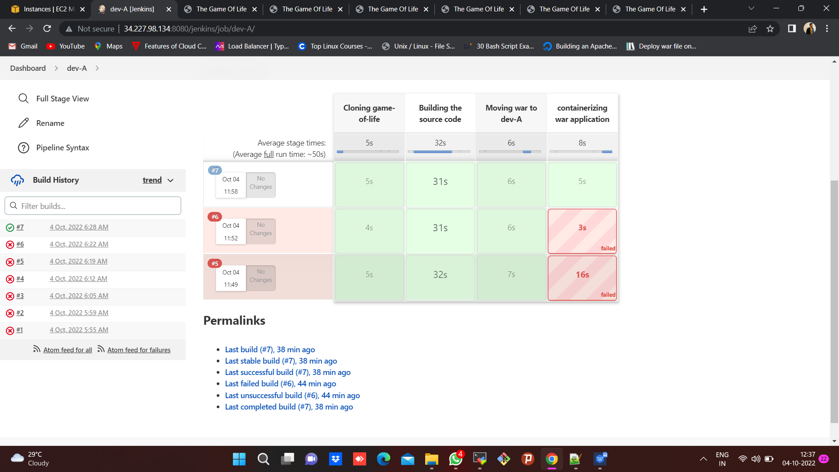

**Two containers are up and running on ports 8080 & 9090 respectively.**

**Image name :** tommy:2.0

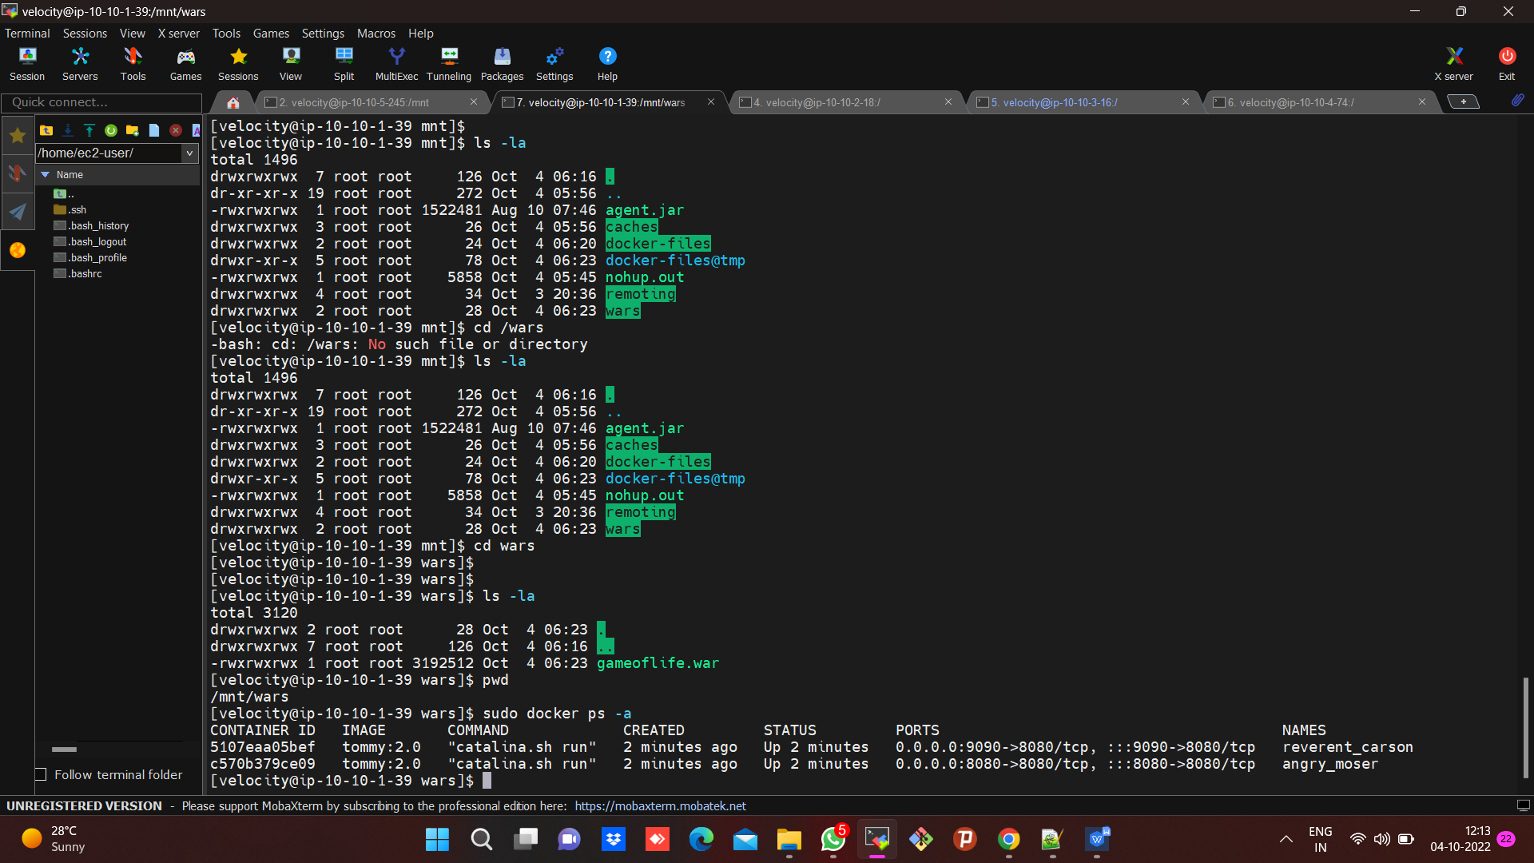

**Output for dev-A**

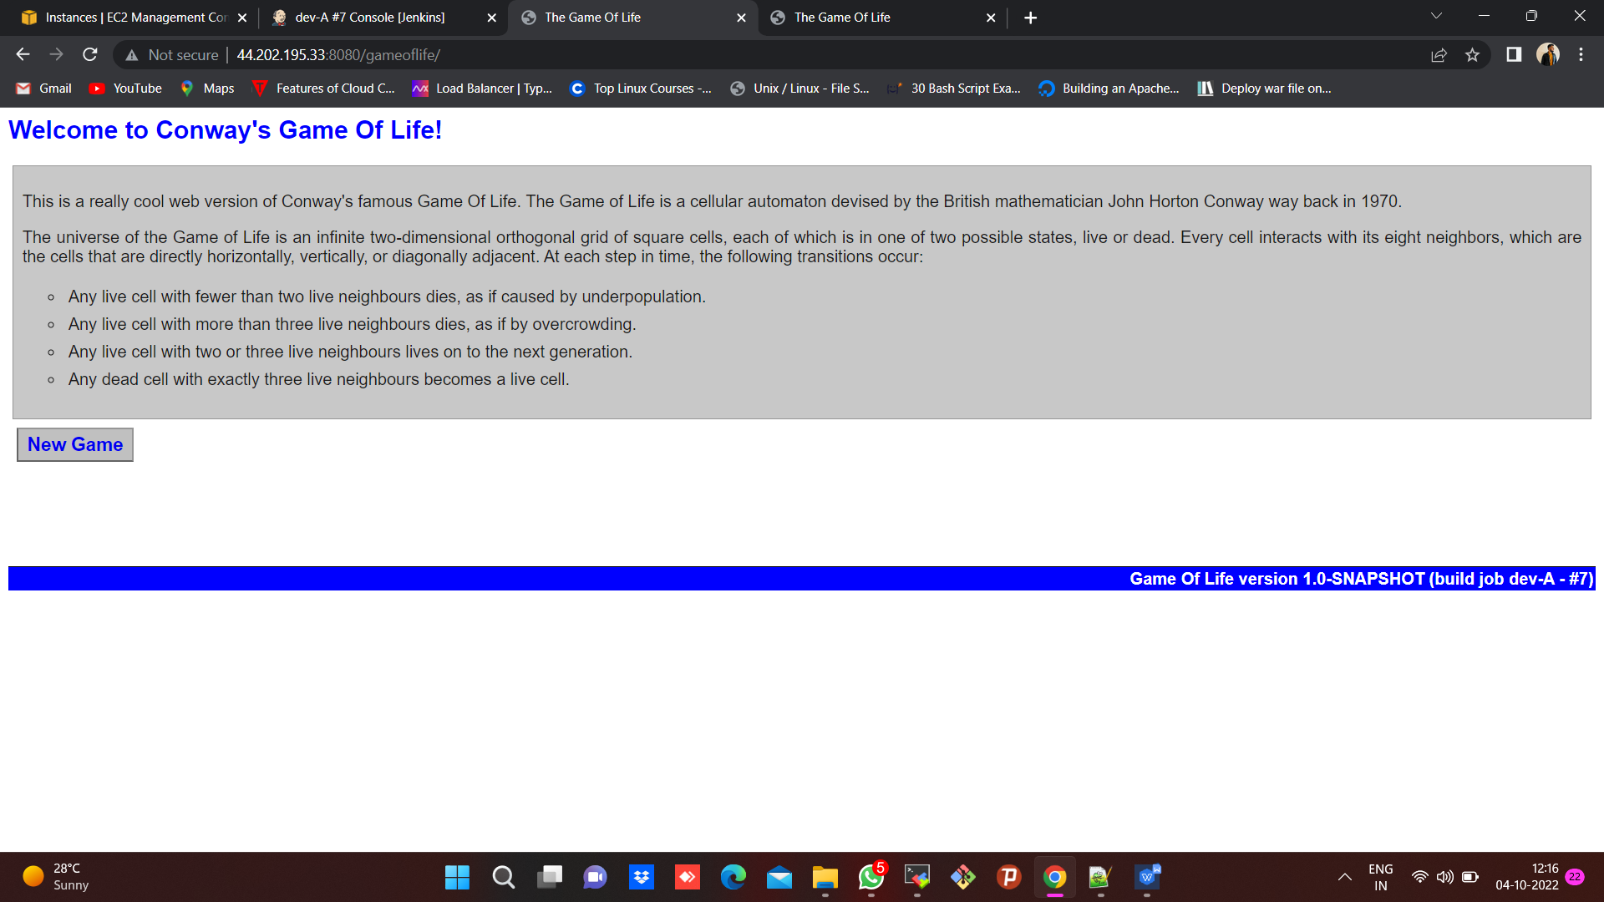

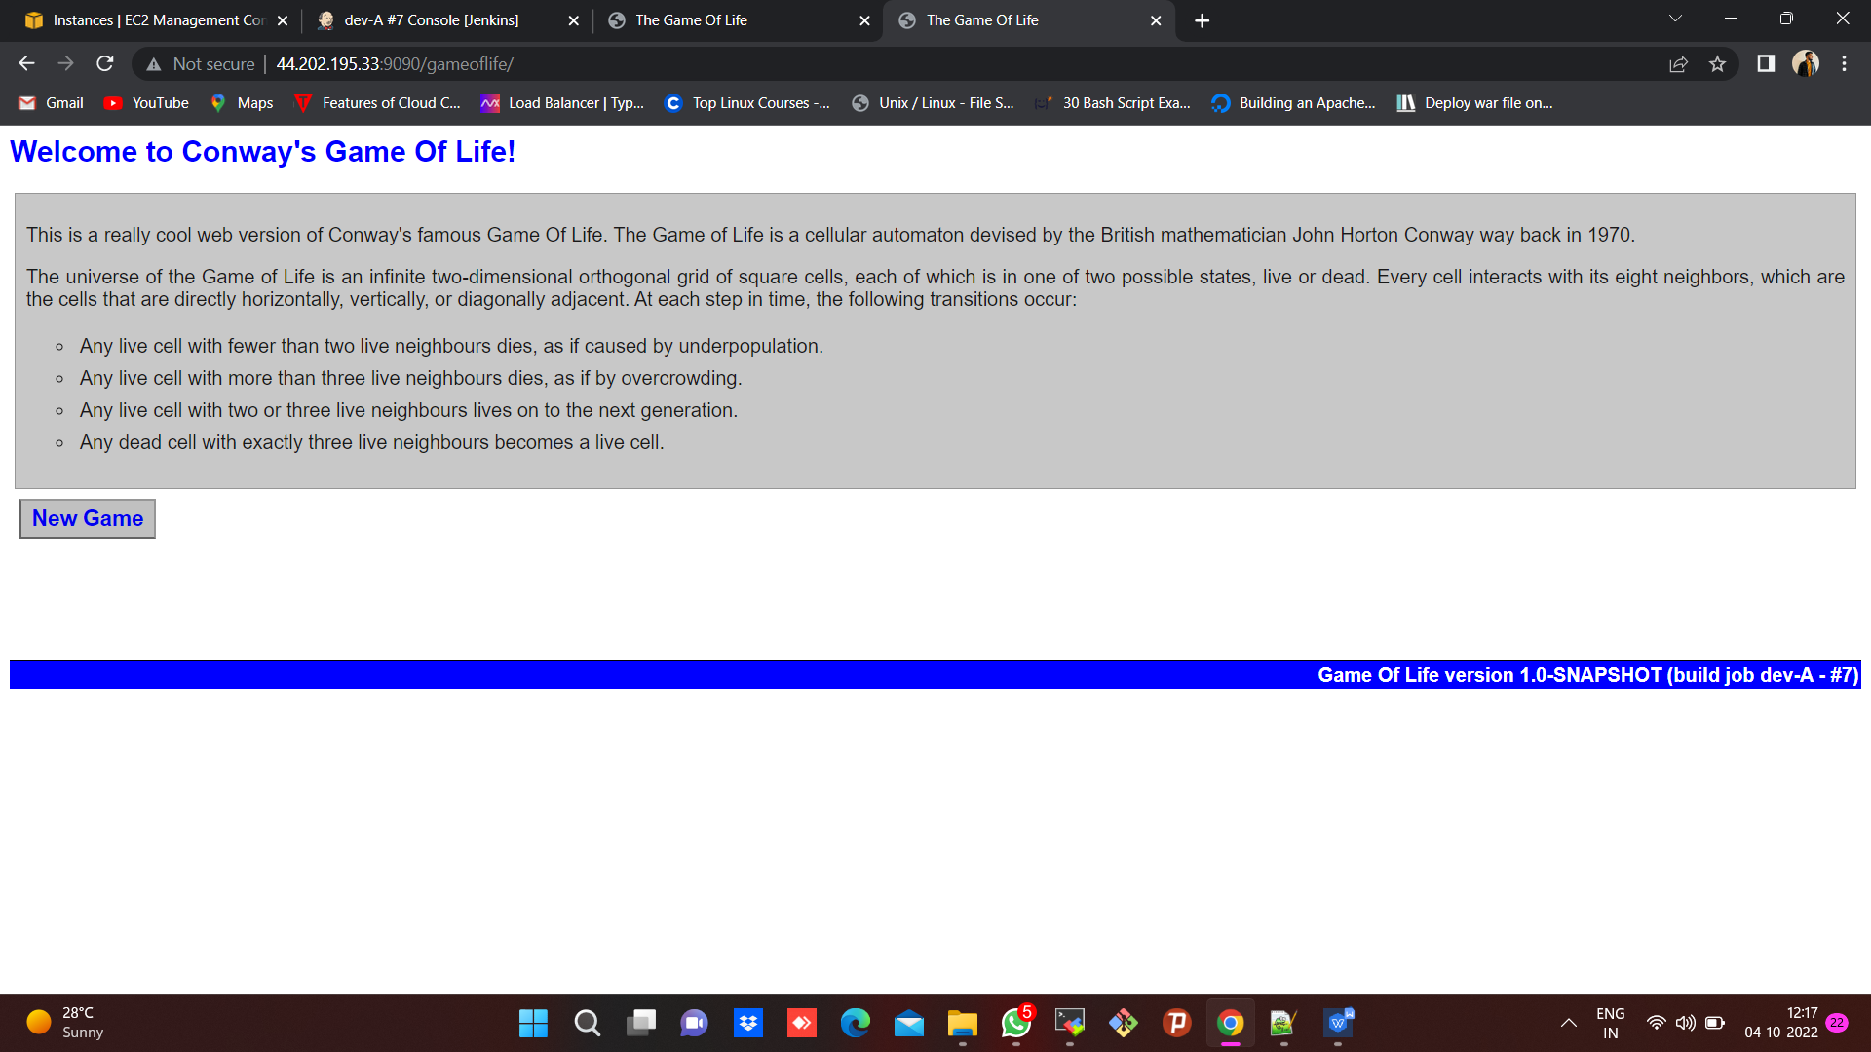

1. **For dev-B**

**Build success for launching two containers using Dockerfile on dev-B machine.**

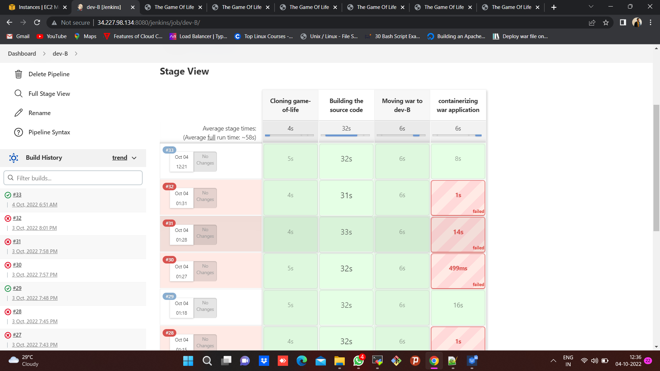

**Two containers are up and running on ports 8080 & 9090 respectively.**

**Image name :** tommy:1.0

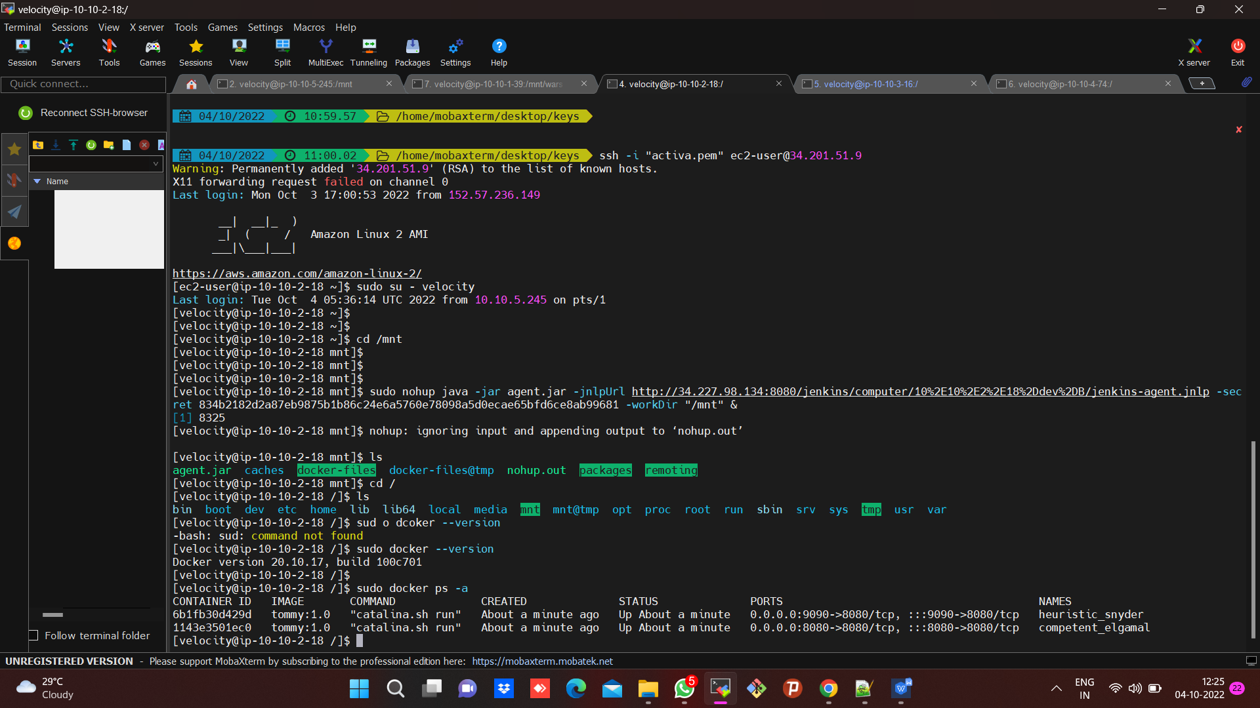

**Output for dev-B :**

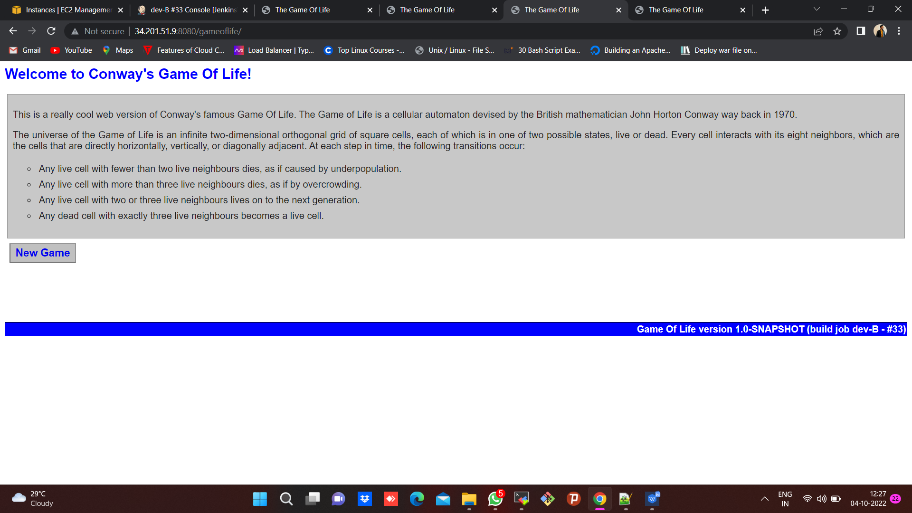



1. **For qa-A :**

**Build success for launching two containers using Dockerfile on qa-A machine.**

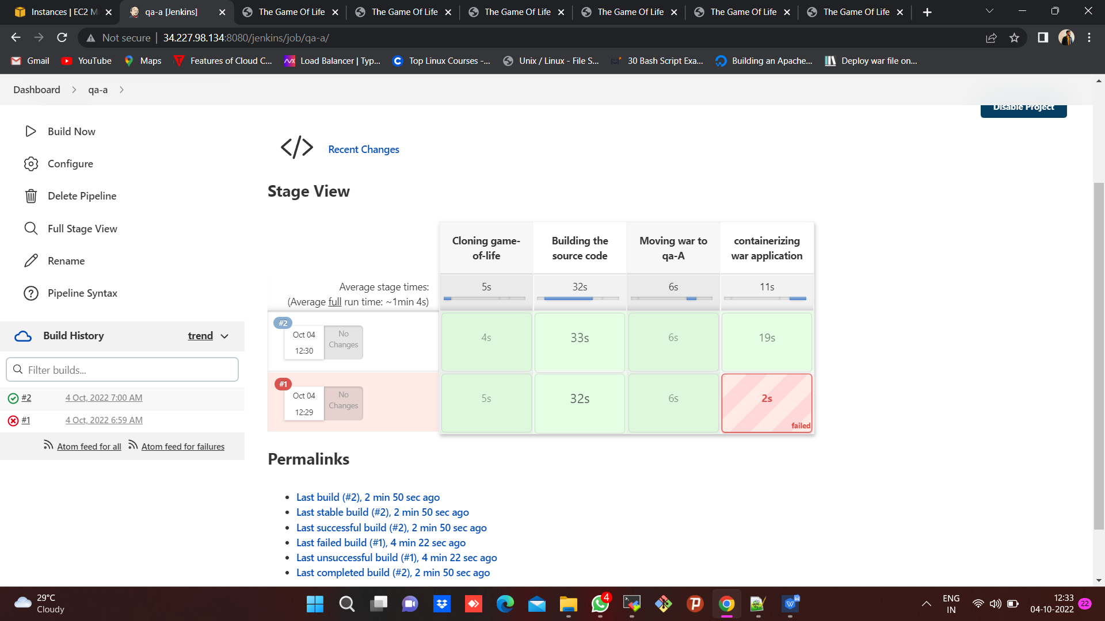

**Two containers are up and running on ports 8080 & 9090 respectively.**

**Image name :** tommy:3.0

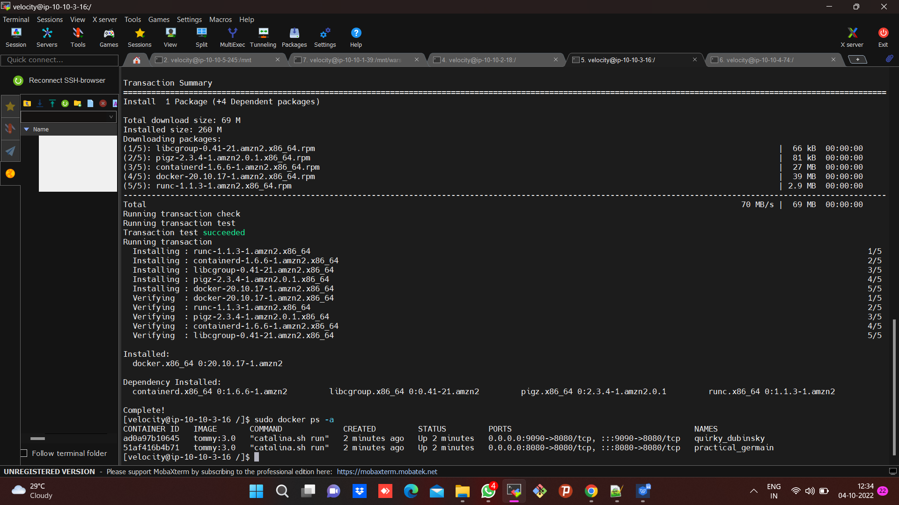

**Output for qa-A :**

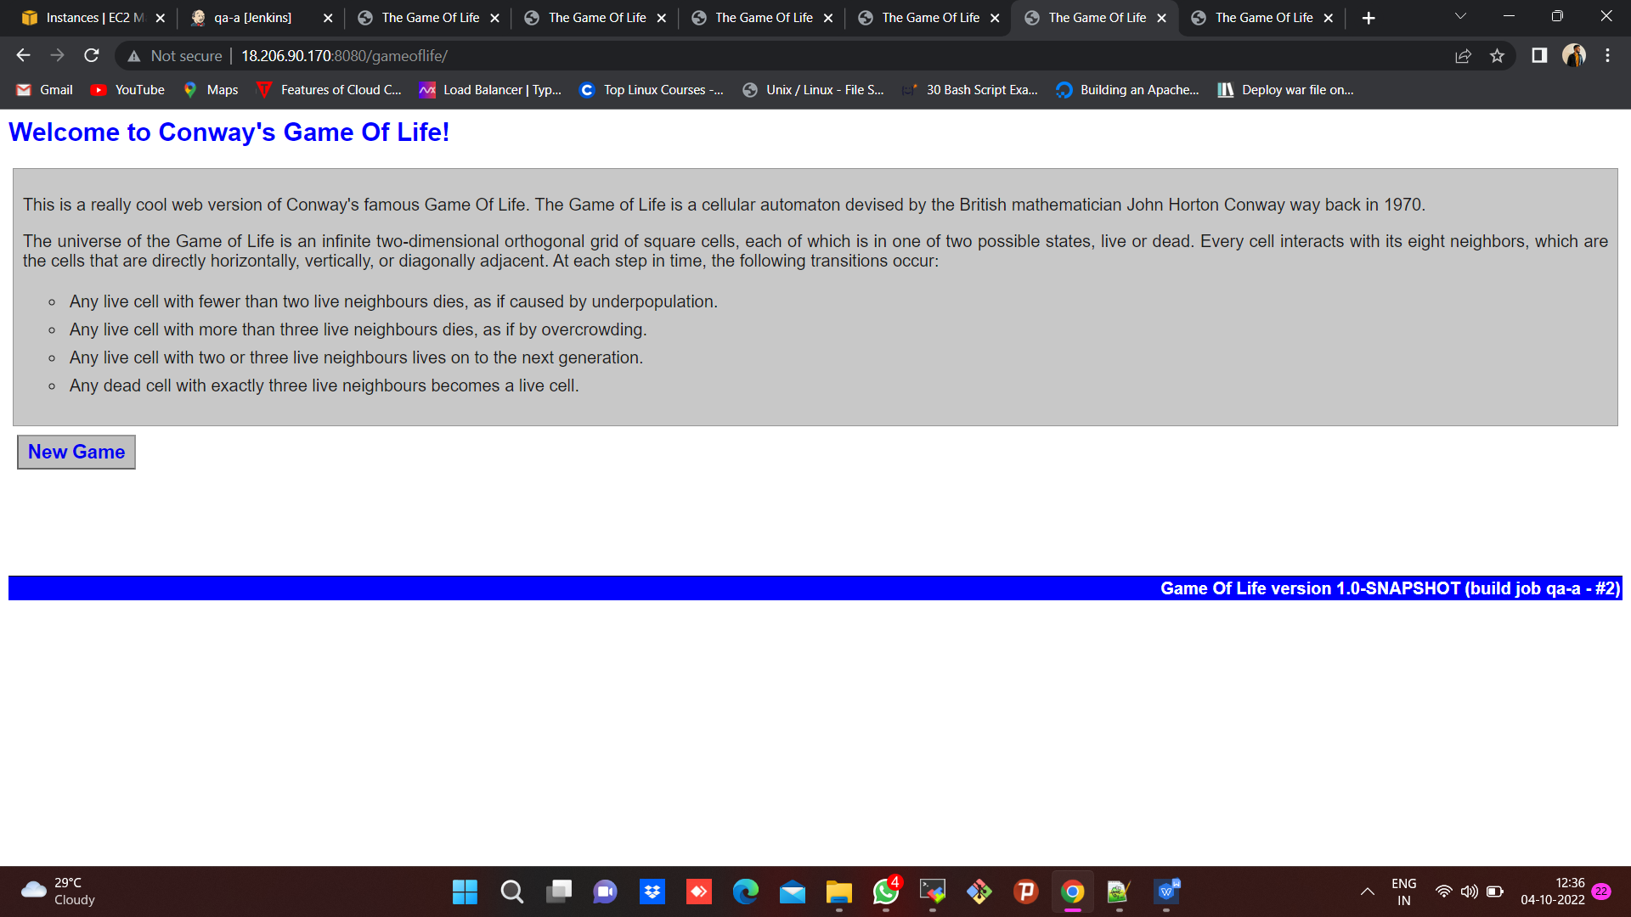

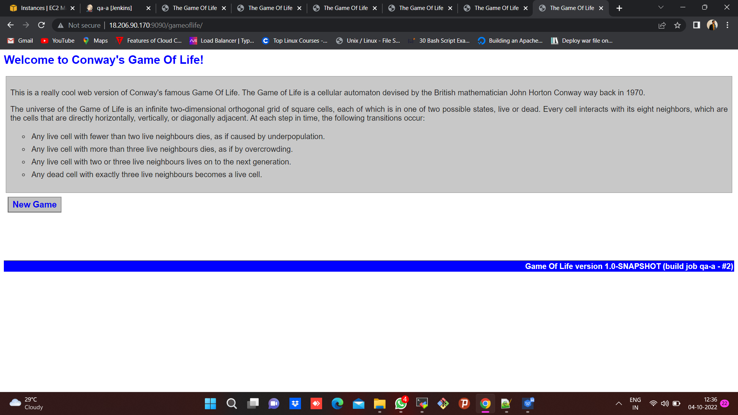

1. **For qa-B :**

**Build success for launching two containers using Dockerfile on qa-B machine.**

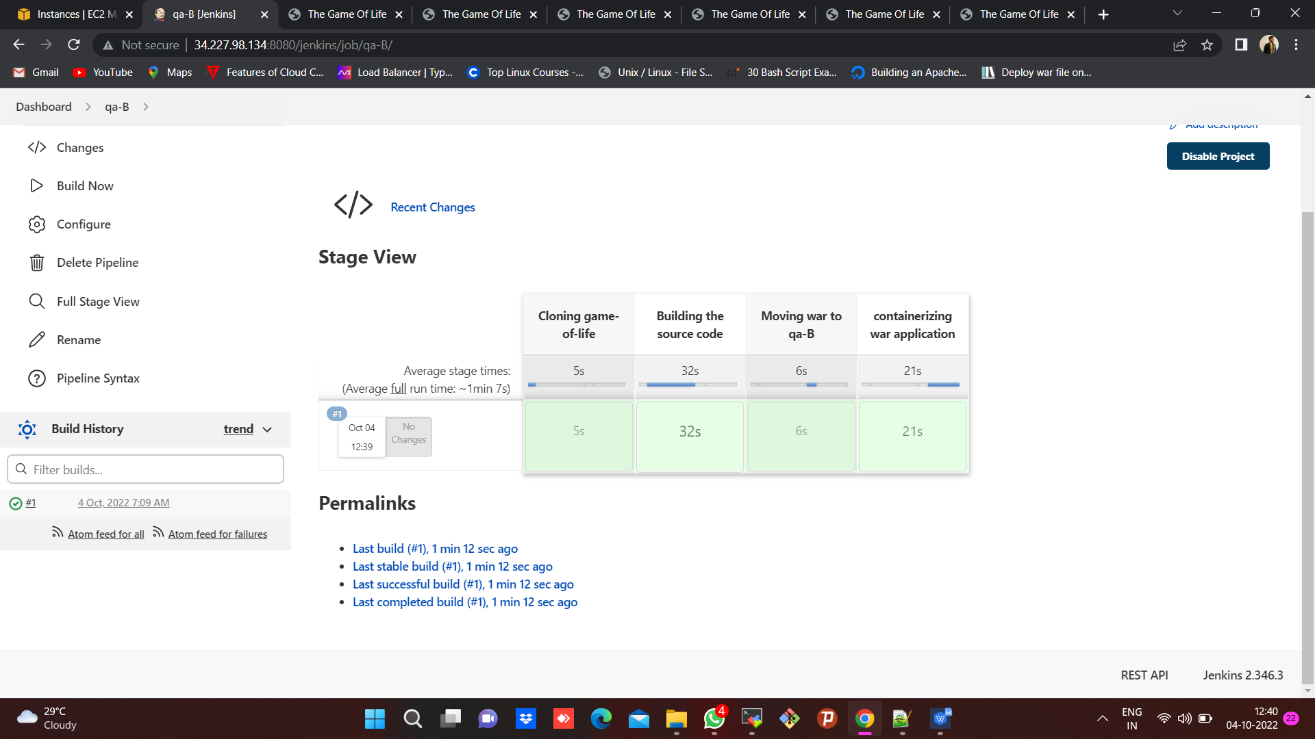

**Two containers are up and running on ports 8080 & 9090 respectively.**

**Image name :** tommy:4.0

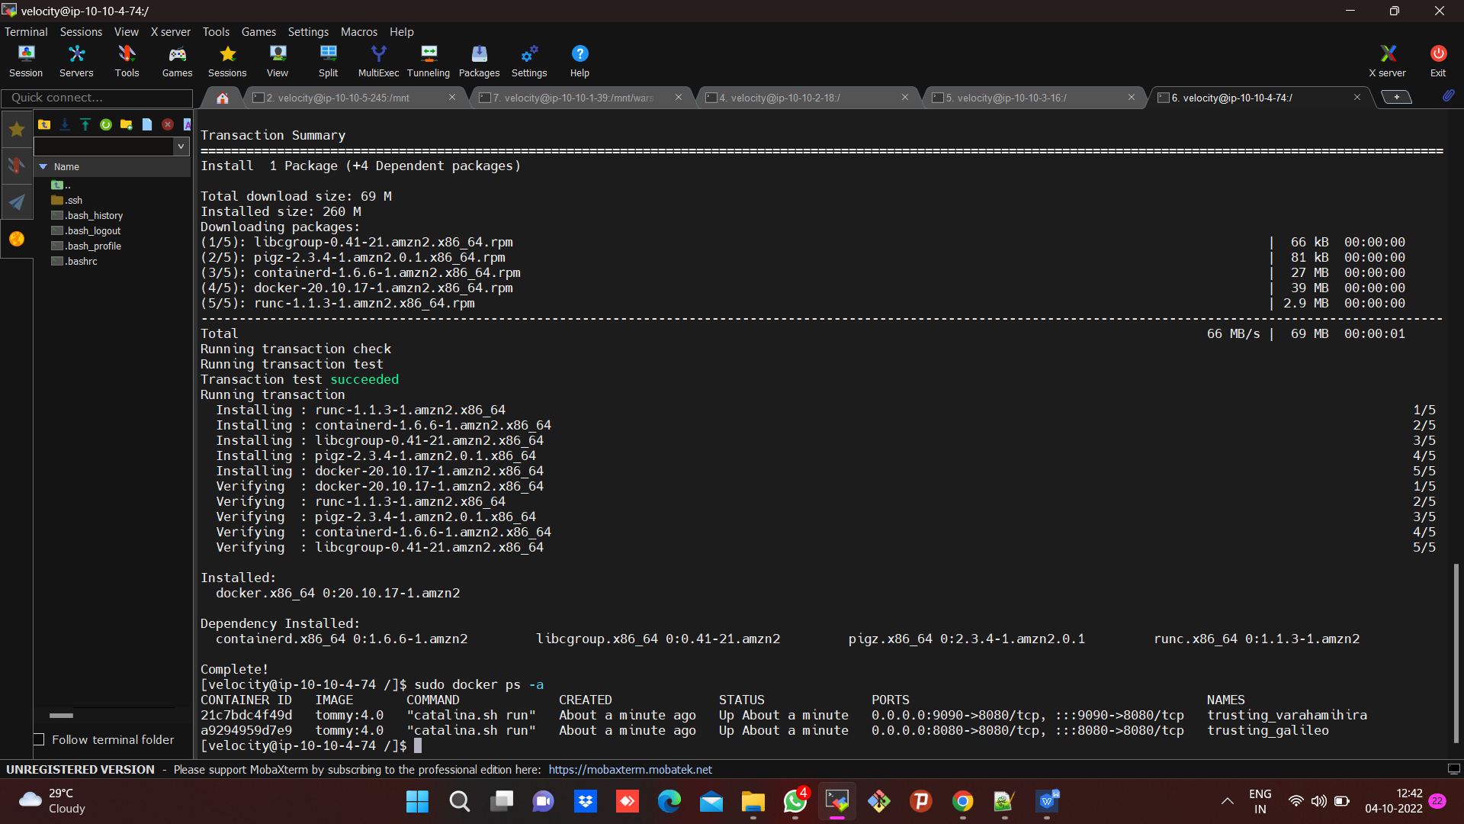

**Output for qa-B :**

